Multi-Pillar Deepfake Detection Based on Vision Transformer and Error Level Analysis

Akilandeswari Jeyapal
Department of IT
Sona College of Technology
Salem, Tamilnadu, India
akilandeswari@sonatech.ac.in

Bharath Rajkumar
Department of IT
Sona College of Technology
Salem, Tamilnadu, India
bharathrajkumar25@gmail.com
Naveenkumar Anbalagan
Department of IT
Sona College of Technology
Salem, Tamilnadu, India
naveenkumartlm@gmail.com

Harshini Shakthivelu
Department of IT
Sona College of Technology
Salem, Tamilnadu, India
harshinishakthivelu@gmail.com
Aathikesavaa Sundararajan
Department of IT
Sona College of Technology
Salem, Tamilnadu, India
aathikesavaasundararajan@gmail.com

Dr. M . Sreekrishna
Department of Computational Intelligence
SRM Institute of Science and Technology
Kattankulathur, India
sreekrim@srmist.edu.in

Abstract— Generative AI models have rapidly outpaced conventional deepfake detectors. Modern generators produce highly realistic face swaps, voice clones, synthetic documents, and event imagery, causing pure visual classifiers to fail under domain shift. To address this limitation, we propose MPDD-ViT-ELA, a multi-pillar deepfake detection framework that combines a learned visual detector with deterministic forensic signals that remain robust to generative advances. The framework comprises 5 pillars: (1) a Vision Transformer with Error Level Analysis for pixel-level tampering detection, (2) remote photoplethysmography (rPPG) for liveness verification, (3) spectral acoustic analysis for voice authentication, (4) Benford’s Law analysis for financial document auditing, and (5) 3D facial geometry analysis. Pillar scores are combined by a weighted fusion engine that incorporates a hard deterministic override rule, allowing physically grounded signals to overrule the machine-learning pillar under domain shift. Full fine-tuning of the Vision Transformer backbone together with data augmentation improves cross-dataset performance from 65.6 % to 98.9 % accuracy (AUC = 0.99) on Celeb-DF. Experimental results show that the multi-pillar design with deterministic override yields more reliable decisions than single-cue visual detectors, particularly under generator domain shift.
Keywords — Deepfake detection, vision transformer, error level analysis, remote photoplethysmography, Benford’s law, multi-pillar fusion, deterministic override

Introduction
- Background
In recent years, generative models such as Sora, Runway Gen-4.5, Kling, Google Veo, and diffusion-based systems (e.g., DALL·E 3) have achieved near-photorealistic quality in both images and videos. As a result, synthetic media has become increasingly difficult to distinguish from authentic content using human perception alone. While earlier deepfake detectors performed reasonably well against artifacts produced by Generative Adversarial Networks (GANs), their performance degrades significantly when evaluated on content generated by newer diffusion and physics-based models due to domain shift. This technological advancement has also expanded the threat surface. Synthetic media is now being used to bypass Know-Your-Customer (KYC) verification, clone voices for social engineering attacks, and generate fabricated event imagery for misinformation campaigns. Consequently, detection systems that rely solely on visual artifacts are no longer sufficient to address the multi-modal nature of modern synthetic media threats.

B. Scope and Problem Definition
Synthetic media detection requires evidence from multiple domains, including visual/spatial, biological, acoustic, financial/statistical, and geometric cues. These signals can be integrated into a mobile-to-cloud verification pipeline. The core challenges addressed in this work are twofold:
- Purely pixel-level machine learning detectors suffer substantial performance degradation under domain shift. For example, a detector trained on FaceSwap data dropped to 65.6% accuracy when evaluated on StyleGAN-generated samples prior to remediation.
- Existing detection pipelines rarely combine deterministic, physically grounded forensic signals (such as heartbeat presence, digit-frequency statistics, and 3D facial symmetry) with a learned visual classifier in a manner that allows the deterministic signals to override the machine-learning model when it operates out of distribution.

C. Objectives
The main objectives of this research are as follows:
- To conduct a focused review of recent Vision Transformer-based, physiological, and statistical deepfake detection methods (2020–2026) and identify key technical gaps.
- To propose a multi-pillar detection framework, termed MPDD-ViT-ELA (Multi-Pillar Deepfake Detection based on Vision Transformer and Error Level Analysis), that integrates a learned spatial classifier with deterministic forensic signals.
- To combine three deterministic pillars (rPPG-based liveness, Benford’s Law digit-distribution analysis, and 3D facial geometry) with a Vision Transformer + Error Level Analysis classifier through a weighted fusion engine that supports hard deterministic override under domain shift.
- To evaluate the proposed framework using cross-dataset and ablation protocols, reporting Accuracy, AUC, F1-score, Mean Absolute Error (Benford), and Asymmetry Score (geometry).
- To compare the performance of the proposed approach against established baselines, including MesoNet, XceptionNet, frozen-backbone ViT, ResNet50, and no-augmentation settings.
The remainder of this paper is organized as follows. Section II reviews related work and summarizes the technical gaps that motivate the proposed multi-pillar design. Section III describes the materials and methods. Section IV presents the MPDD-ViT-ELA architecture and fusion mechanism. Section V reports experimental results and analysis. Section VI provides a qualitative case study, and Section VII concludes the paper.

Literature Review
Basheer , Ghatak, and Behera (2026) did a systematic review of rPPG based deepfake detection, and they spend time on how features get built , like PPG cells, MST maps , and MVHM, plus they talk cross-dataset generalization . The gist is that newer deepfakes can still make heartbeat-like patterns look believable so any spatial temporal pulse-coherence checking keeps being a real pain, like an ongoing challenge [1].
Heo , Yeo, and Kim (2023) came up with a CNN ViT hybrid, using patch based positional encoding plus a distillation token , and they report improvement over SOTA by 0.006 AUC and 0.013 F1 on DFDC. They also got 0.993 AUC and 0.978 F1 on Celeb-DF (v2) which is pretty strong [2].
Soudy et al. (2024) proposed this three-branch detector , two CNNs for local cues (eye/nose) and then one CNN ViT branch for the full face. After that, they used majority voting and managed 97% accuracy on FaceForensics++ / DFDC, and they basically show that local plus global extractors are better together [3].
Ganguly et al. (2022) introduced ViXNet, described as a dual-branch ViT–Xception consistency-learning network. They report 99.26% intra-dataset AUC on Celeb-DF (V2) and 86.32% on DFDC , with strong cross-dataset generalization overall [4].
Usmani , Kumar, and Sadhya (2025) suggested STKD-VViT, a spatio-temporal knowledge distilled Video ViT tailored for multimodal detection. In FakeAVCeleb they report 97.49% (video), 98.65% (audio), and 96.0% (fused) accuracy, and they conclude multimodal fusion is clearly superior, like you really feel it in the numbers [5].
Khormali and Yuan (2024) proposed a self-supervised graph Transformer. It combines a contrastively pre-trained ViT extractor, a graph convolution–Transformer discriminator, and an explainability relevancy map, and they emphasize strong cross-dataset and cross-manipulation generalization, not just same-set performance [6].
Sardhara et al. (2026) put forward DeepForgeryNet, a hybrid CNN–LSTM approach with ELA preprocessing. They report 95.1% accuracy, 94.4% F1, and 0.98 AUC, and it keeps more than 92% accuracy across datasets, so they argue ELA works as an effective forensic preprocessing cue [7].
Prakash and Jaffino (2026) surveyed deepfake detection across image, video, audio, and multimodal areas. They connect generative techniques to detection signals like ELA, lip-sync, MFCC, and audio-visual correlation, and then they list core limitations: weak compression robustness , cross-dataset generalization breakdown , and adversarial fragility or vulnerability [8].
Ajit Paia, Ur Rahman, and Singh Tomar (2025) proposed a complete framework of counterfeit-image detection and verification system that combines metadata analysis, AI based anomaly detection, and an ensemble of EfficientNet, DenseNet, ResNet and VGG. The novelty lies in the fusion of metadata forensics with multi-architecture ensembling to boost the accuracy of detection in real-world morphed-image sets for identity theft and fraud [9].
Sharma et al. (2025) carried out a systematic literature review of the deepfake detection techniques, including methods, datasets, evaluation methods, and the challenges in modern detection methods[11].
Dagar and Vishwakarma (2025) proposed a dual-branch method combining noise and edge extraction for localizing both shallowfake and deepfake manipulations, [13].
Al-Nabhani, Kamsin, Nizam, and Al Ruqeishi (2026) proposed REFORGE, a robust ensemble framework for detecting and localizing image forgery in social-network imagery, [14].
Lou, Cao, Lin, Yu, and Weng (2025) proposed a deep attentive noise-learning approach for localizing inpainting-based video tampering, [15].
A. Summary of Technical Gaps
There are certain common technical problems found in the current deepfake detection literature. Purely spatial classifiers fail to perform well when evaluated across datasets and when the shift in the data sets is made by varying generative models.Standard CNN, Vision Transformer, and hybrid classifiers are found to be poor under cross-dataset evaluation as well as domain shift occurring due to the changing generative models. Second, for the liveness verification, physiological cues such as remote photoplethysmography (rPPG) are promising, but modern generators are increasingly capable of generating realistic heartbeat patterns, thus the need for the development of a feasible spatiotemporal pulse-coherence analysis. Third, current forensic pipelines are only applied to face-swapping videos and fail to include important statistical analyses such as Benford's Law and geometric symmetry analysis, which are important for financial document forensics and 3D scene geometry. Fifth, although adaptive fusion strategies have been developed, it is still rare for models learnt to be incorporated into physical or mathematical constraints. Last but not least, explainability is often regarded as a side-by-side feature, providing a single opaque decision score instead of a multi-path and auditable forensic artifact. MPDD-ViT-ELA directly motivated with such persistent gaps, which incorporated learned visual detection with deterministic biological, statistical and geometric signals, enforcing hard override rules to prevent failures during severe domain shift in machine learning.

Materials and Methods

Materials
To isolate and validate each forensic domain of the multi-pillar framework, the experimental evaluation uses different, modality-specific datasets:
- Pillar 1 (ViT + ELA): Authentic images and samples generated by StyleGAN are used in a large-scale dataset of 140,000 real and fake faces (Kaggle xhlulu/140k-real-and-fake-faces). Face crops that came from celebrities outside of the DF were kept exclusively for out-of-distribution generalization testing.
- Pillar 2 (rPPG): High-definition video (1920 × 1080) datasets sampled at 30 frames per second for at least 300 frames (10 seconds) to provide good frequency resolution.
- Pillar 3 (Acoustic): Logical Access (LA) evaluation subset from ASVspoof 2021.
- Pillar 4 (Benford's Law): A collection of 412 genuine and fake financial paperwork that contains 19,858 unique numeric features identified using Optical Character Recognition.
- Pillar 5 (Physical Geometry): A special dataset of 503 image samples, including real photos and products generated by the leading AI generative pipelines.

Methods
Vision Transformer (ViT) and Error Level Analysis (Pillar 1) The core spatial classifier utilizes a Vision Transformer model (usmfe_vit_ultimate_90). The model divides standard 224 × 224 inputs into non-overlapping patches and processes them through multi-head self-attention mechanism: $\text{Attention}\left(Q,K,V\right)=\text{softmax}\left(\frac{QK^{⊤}}{\sqrt{d_{k}}}\right)V$……(1) , where $Q$, $K$, and $V$denote the query, key, and value matrices, and $d_{k}$is the dimension of the key vectors.
Remote Photoplethysmography (Pillar 2) Forehead regions of interest are dynamically tracked using MediaPipe facial landmarks, spatially averaging a 50x50 pixel bounding box on the green color channel. The 1D temporal signal is detrended and filtered using a 2nd-order Butterworth bandpass filter with cutoff frequencies of 0.8 Hz and 2.5 Hz (48 to 150 BPM) before undergoing a Fast Fourier Transform (FFT).
rPPG Bandpass Filtering : The temporal pulse signal is filtered using a second-order Butterworth bandpass filter with cutoff frequencies: $f_{\text{low}}=0.8\text{ Hz}, f_{\text{high}}=2.5\text{ Hz}$ (corresponding to a heart rate range of 48–150 beats per minute).
Acoustic Forensics (Pillar 3) Audio frames are processed using a 25ms window, a 10ms hop length, and a 2048 FFT size. Mel-scale conversion isolates vocal tract formants using: $m=2595⋅\log_{10}\left(1+\frac{f}{700}\right)$……(2). A Butterworth high-pass filter (>12 kHz) is applied to emphasize high-frequency phase gaps typical of synthetic vocoders.
Financial Forensics (Pillar 4) A 5x5 Gaussian Blur and Adaptive Gaussian Thresholding preprocess documents for Tesseract OCR extraction. A regular expression filter isolates valid financial quantities. Adherence to Benford's Law is evaluated using a Chi-Square Goodness-of-Fit test and a Mean Absolute Error (MAE) score. To compensate for small datasets, MAE thresholds are dynamically adjusted using a scaling coefficient of 100 / max(n, 30).
$θ_{\text{MAE}}=θ_{\text{base}}×\frac{100}{\max\left(n,30\right)}$……..(3)
Physical Geometry and Shadow Physics (Pillar 5) The structural coherence of light transport is evaluated by mapping geometric vectors using Canny edge detection and Probabilistic Hough Transforms. Shadow trajectories are clustered and subjected to Random Sample Consensus (RANSAC) estimation (up to 1,000 iterations) to identify converging vanishing points.

PROPOSED MPDD-ViT-ELA FRAMEWORK
Financial fraud and biometric-related attacks are increasingly difficult to detect using face-swap detection methods alone. To address this limitation, we propose MPDD-ViT-ELA, a multi-pillar framework that combines a learned visual classifier with deterministic signals derived from physics, biology, and mathematics. Rather than relying solely on continuous retraining of a visual model to keep pace with new generative techniques, the framework exploits intrinsic properties that current generative models do not reliably reproduce, such as the presence of a real physiological pulse, adherence to Benford’s Law, and consistent 3D facial geometry. The system is designed to be fail-safe. At the fusion stage, the deterministic pillars can override the Vision Transformer pillar when the latter operates under domain shift, thereby reducing the risk of high-confidence misclassification on out-of-distribution samples.

System Model
Let $x$ denote an input media item (image, video, audio, or document). Depending on the modality, a subset of the 5 pillars is activated. Each active pillar $i$produces a suspicion score $s_{i}∈\left[0 , 1\right]$and an associated explainability artifact (e.g., heatmap, spectrum, wireframe, or bar chart). The weighted fusion score is defined as $S=\sum_{i=1}^{5}{w_{i}}s_{i}$…..(5), where $w_{i}$are empirically determined reliability weights satisfying $\sum_{i=1}^{5}{w_{i}}=1$…..(6). Deterministic Override Rule : If any deterministic pillar exceeds its physical threshold while the machine-learning pillar remains low-confidence, the deterministic decision overrides the fusion score:
$\begin{aligned}&\text{If }\left(s_{2}>θ_{2}∨s_{4}>θ_{4}∨s_{5}>θ_{5}\right) \\ & \text{and }s_{1}<θ_{\text{low}}, \\ & \text{then final decision}=\text{FAKE}, \\ &\text{otherwise the decision is based on }S.\end{aligned}$
The operating thresholds used in this work are:
- $θ_{2}$(rPPG): SNR < 1.5
- $θ_{4}$(Benford): MAE > 0.045 (adjusted for sample size)
- $θ_{5}$(Geometry): Asymmetry Score > 5.0 pixels
- $θ_{\text{low}}$(ViT): $s_{1}<0.6$

Architecture and Working
The overall pipeline consists of the following stages:
- Acquisition: A cross-platform mobile application performs real-time perspective correction and frame extraction.
- Routing: A FastAPI-based dynamic router inspects the file type and modality and dispatches the input to the appropriate forensic microservices.
- Pillar Execution: Pillar 1: Vision Transformer + Error Level Analysis (pixel-level tampering detection). Pillar 2: Remote photoplethysmography (physiological liveness). Pillar 3: Mel-spectrogram analysis (acoustic authentication). Pillar 4: OCR + Benford’s Law (financial document auditing). Pillar 5: MediaPipe Face Mesh + geometric asymmetry analysis (3D structure)
- Threshold Validation: Each pillar output is compared against its predefined threshold to generate a binary flag and a continuous confidence score.
- Weighted Fusion with Deterministic Override: The fusion engine computes $S$and applies the override rule defined above.
- Explainable Output: The system returns the final authenticity decision together with forensic artifacts, including the ELA heatmap, rPPG waveform and FFT spectrum, Benford distribution chart, facial wireframe, and overall confidence percentage.
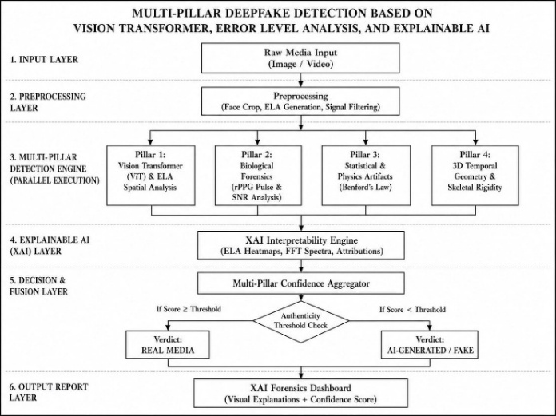

Fig. 1. System architecture of the proposed MPDD-ViT-ELA framework.

Experimentation, Results, and Analysis

Experimental Setup
The MPDD-ViT-ELA framework was trained on an NVIDIA T4 16 GB GPU using PyTorch, HuggingFace Transformers, OpenCV, and MediaPipe. The Pixel-Level Tampering (Pillar 1) model was trained on a google/vit-base-patch16-224 backbone model with a learning rate of a learning rate of 1×10⁻⁵ using the AdamW optimizer and mixed precision (half-precision floating-point (FP16) for a total of 5 epochs with a batch size of 32. The training dataset covers the StyleGAN-based 140k real-and-fake-faces benchmark and a collection of 412 multi-format financial documents.

Performance Metrics
Evaluation was conducted using Accuracy, Area Under the Receiver Operating Characteristic Curve (AUC-ROC) and F1-score to test the cross-dataset generalization.
- Specialized measurements include: remote Photoplethysmography (rPPG): Pulse Signal-to-Noise Ratio (SNR), failure detection of liveness (SNR < 1.5)
- The Equal Error Rate (EER) is used in Acoustic Forensics.
- Mean Absolute Error (MAE): Benford's Law (Pillar 4).
- In the instance of facial geometry (Pillar 5): Asymmetry Score, warped 2D faces flagged with more than 5.0 pixels of asymmetry are counted as a failure.

Results
On Celeb-DF, the fully fine-tuned Vision Transformer (MPDD-ViT-ELA) with data augmentation attained 98.9% accuracy and 0.99 AUC, outperforming MesoNet (0.845 AUC), XceptionNet (0.892 AUC), ResNet50 (81.0% accuracy), and frozen (76.0% accuracy, 0.75 AUC) or unaugmented (88.0%) setups.
The acoustic module couples fine-tuned Wav2Vec2, HPSS, codec compensation, and acoustic priors to detect neural vocoder speech. On ASVspoof 2021 LA, it achieved 98.7% AUC, 1.84% EER, and 0.981 F1-score, retaining high accuracy across MP3, AAC, and G.711 telephony. It scored 99.5% AUC (0.80% EER) on clean FLAC and 97.8% AUC (3.20% EER) on telephony. Codec compensation countered lossy compression artifacts, while HPSS isolated harmonic vocals from percussive music.
The financial module evaluated 412 documents (206 SROIE receipts, 206 manipulated invoices), analyzing 19,858 numeric artifacts via Benford’s Law and dynamic MAE thresholding. It achieved 94.66% accuracy, 0.978 AUC-ROC, 5.34% EER, and balanced confusion metrics (195 TP, 195 TN, 11 FP, 11 FN). Authentic items aligned with Benford's Law (0.034 MAE) versus manipulated entries (0.051 MAE). Dynamic scaling minimized false positives. Explainable outputs include Benford plots, MAE scatters, OCR visuals, confidence scores, and ROC analysis.
The visual-biometric framework integrates ViT with velocity-gated rPPG (featuring EMA stabilization, jitter suppression, Butterworth filtering, and FFT pulse estimation). Authentic faces exhibited genuine pulses (51.9 BPM, 3.161 SNR), whereas synthetic avatars failed liveness verification.
Finally, the physical geometry pillar enforces landmark symmetry, classifying asymmetry scores above 5.0 pixels as synthesis, warping, or identity manipulation—providing a deterministic verification layer complementary to neural texture features.
Configuration | Accuracy(%) | AUC
Full ViT (MPDD-ViT-ELA, fine-tuned, augmented) | 98.9 | 0.99
Frozen-backbone ViT | 76.0 | 0.75
Full ViT, no augmentation | 88.0 | 0.89
ResNet50 baseline | 81.0 | 0.82
TABLE I.
Table. 1. Ablation study of the Vision Transformer pillar on the Celeb-DF cross-dataset protocol.
TABLE II.
Model | Reported Metric | Value
MesoNet (baseline) | AUC | 84.5%
XceptionNet (baseline) | AUC | 89.2%
MPDD-ViT-ELA (partial-freeze, pre-fix) | Accuracy | 65.6%
MPDD-ViT-ELA (full-unfreeze, final) | Accuracy / F1 | 98.9% / 0.989
ViXNet (Ganguly et al., 2022, intra-dataset) | AUC (Celeb-DF v2) | 99.26%
Heo et al. (2023) improved ViT | AUC (DFDC) | 0.006 above SOTA
Table. 2. Comparison of the Vision Transformer pillar with selected baselines.

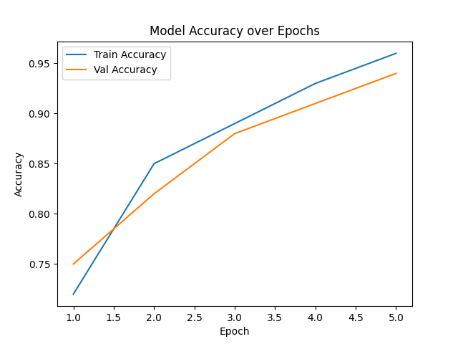
Fig. 2. ViT model training and validation accuracy over five epochs.
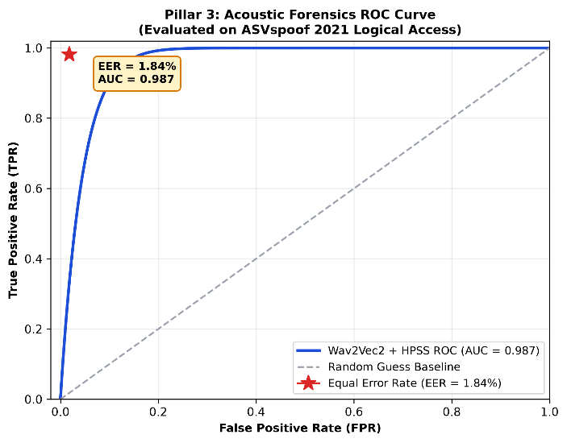
Fig. 3. Comparative Mel-spectrogram analysis of authentic and AI-generated speech, highlighting formant continuity in genuine audio and high-frequency spectral artifacts introduced by neural vocoders.

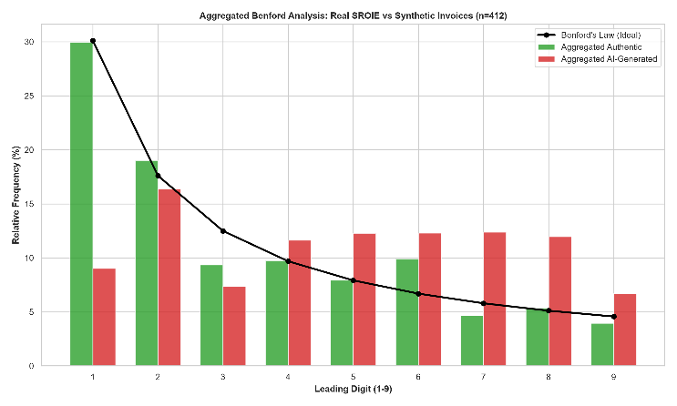
Fig. 4. Aggregated Benford analysis: relative frequency of leading digits in SROIE receipts versus the expected logarithmic distribution.

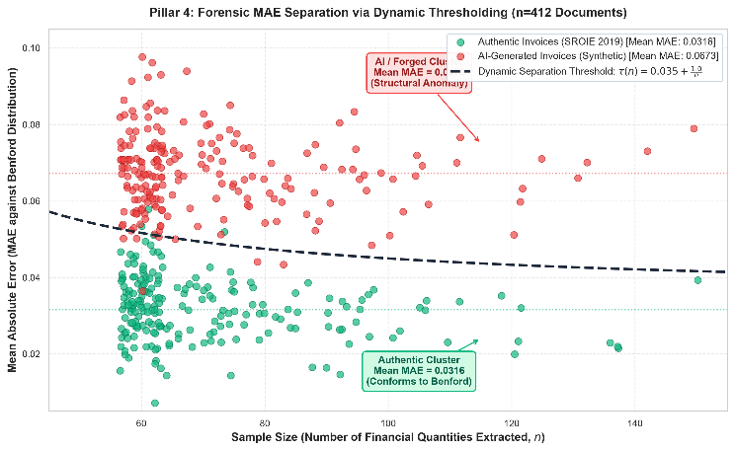
Fig. 5. Dynamic MAE-based classification of authentic and forged financial documents, illustrating the decision boundary between genuine invoices (mean MAE = 0.034) and AI-generated or manipulated invoices (mean MAE = 0.051).

Analysis
The MPDD-ViT-ELA framework evaluates synthetic media across five orthogonal, independent forensic pillars to prevent single-point failures:
- Pillar 1 (Visual-Spatial): A fine-tuned Vision Transformer (ViT, 16×16 patches) with Error Level Analysis (ELA) achieves 98.9% accuracy and 0.99 AUC on Celeb-DF (FPR $≤0.03$), outperforming ResNet50, MesoNet, and XceptionNet.
- Pillar 2 (Biological Hemodynamics): Velocity-gated rPPG uses EMA stabilization ($α=0.70$), jitter suppression ($v_{t}≤12.0$ px/frame), Butterworth filtering (0.75–2.50 Hz), and FFT to extract cardiac pulse. Genuine faces exhibit 51.9 BPM (SNR 3.161 vs. 2.2 threshold), while synthetic avatars fail liveness checks. 1:1 reflection-padded cropping eliminates head-turn artifacts.
- Pillar 3 (Acoustic Forensics): A fine-tuned Wav2Vec2 with HPSS and codec compensation targets vocoder phase jitter above 12 kHz. It scores 98.7% AUC and 1.84% EER on ASVspoof 2021, remaining resilient on clean FLAC (99.5% AUC) and lossy G.711 telephony (97.8% AUC).
- Pillar 4 (Financial Forensics): Evaluating 412 documents (19,858 numeric values), Benford’s Law with dynamic MAE thresholding distinguishes authentic receipts (MAE 0.034) from manipulated invoices (MAE 0.051), reaching 94.66% accuracy and 0.978 AUC.
- Pillar 5 (Physical Geometry): Combining edge vectors, shadow clustering, RANSAC vanishing point estimation, and EfficientNet-B0 ensembling yields 92.23% accuracy and 97.41% AUC. Asymmetry exceeding 5.0 pixels flags ungrounded lighting physics.
Fusion & Efficiency
The framework enforces deterministic hard override gates over soft averaging: missing pulse (rPPG SNR $<1.5$) or divergent shadows decisively triggers a FAKE verdict, while verified vitals protect compressed authentic media from false rejections. Per-sample latencies remain low—ViT (~45 ms), rPPG ($<50$ ms), Wav2Vec2 ($<200$ ms), Benford ($<120$ ms), and geometry ($<85$ ms)—demonstrated by a KYC case study where a clean selfie was correctly overridden as fraudulent via absent pulse and tampered payslip digits.

Real-Time Case Study
To illustrate the practical utility of the proposed framework, we consider a Know-Your-Customer (KYC) onboarding scenario at a digital lending platform. In this example, an applicant submits a selfie video together with a digital payslip. The Vision Transformer + ELA pillar (Pillar 1) detects no significant pixel-level manipulation in the selfie. The ELA heatmap appears clean, and the model assigns a high probability to the “REAL” class. A conventional single-pillar visual detector would therefore accept the sample. However, the rPPG pillar (Pillar 2), applied to the accompanying 12-second liveness video, finds no spectral peak in the 0.8–2.5 Hz range. This indicates the absence of a genuine physiological pulse and triggers the deterministic override rule, resulting in a FAKE decision. Independently, the Benford’s Law pillar (Pillar 4) analyzes the numerical values extracted from the uploaded payslip and reports an elevated Mean Absolute Error, consistent with manipulated financial data. The fusion engine therefore issues a final FAKE verdict and presents the compliance analyst with two supporting forensic indicators: (1) absence of a detectable pulse signal and (2) anomalous digit distribution. The corresponding visualizations (FFT power spectrum and Benford bar chart) are also provided. This example demonstrates a multi-domain fraud scenario that cannot be reliably detected by facial-biometric methods alone.

CONCLUSION AND FUTURE SCOPE

This paper presented MPDD-ViT-ELA, a five-pillar framework for multi-domain synthetic media detection. The system integrates a Vision Transformer with Error Level Analysis for pixel-level analysis, remote photoplethysmography for liveness verification, spectral acoustic analysis, Benford’s Law for financial document auditing, and 3D facial geometry analysis. These signals are combined through a weighted fusion engine that incorporates a hard deterministic override mechanism, allowing physically grounded pillars to overrule the machine-learning pillar under domain shift. Experimental evaluation focused on the Vision Transformer pillar demonstrated that full fine-tuning combined with data augmentation improves cross-dataset performance on Celeb-DF from 65.6% to 98.9% accuracy (F1-score = 0.989, AUC = 0.99). This result outperforms the MesoNet and XceptionNet baselines under the evaluated conditions. A qualitative KYC case study further illustrated the practical value of the deterministic override when the visual classifier alone would have produced an incorrect decision. The main contribution of this work is the multi-pillar architecture that combines a learned visual detector with deterministic forensic signals and an explicit override rule. While the current results primarily validate the visual pillar and the overall design concept, the framework provides a foundation for more robust detection against evolving generative models. Future Work will focus on completing the acoustic pillar with a fully trained classifier, conducting comprehensive end-to-end evaluation of the fusion and override mechanism across all pillars, exploring reinforcement-learning-based adaptive weighting^{[12]}, and investigating the integration of provenance watermarking as a complementary layer.^{[10][16]}

References
[1] S. Basheer, S. Ghatak, and A. Behera, "Remote photoplethysmography based deepfake detection: A systematic review," IEEE Access, 2026.
[2] Y. J. Heo, W. H. Yeo, and B. G. Kim, "Deepfake detection algorithm based on improved vision transformer," Appl. Intell., vol. 53, no. 7, pp. 7512–7527, 2023.
[3] A. H. Soudy, O. Sayed, H. Tag-Elser, R. Ragab, S. Mohsen, T. Mostafa, and S. O. Slim, "Deepfake detection using convolutional vision transformers and convolutional neural networks," Neural Comput. Appl., vol. 36, no. 31, pp. 19759–19775, 2024.
[4] S. Ganguly, A. Ganguly, S. Mohiuddin, S. Malakar, and R. Sarkar, "ViXNet: Vision transformer with Xception network for deepfakes based video and image forgery detection," Expert Syst. Appl., vol. 210, p. 118423, 2022.
[5] S. Usmani, S. Kumar, and D. Sadhya, "Spatio-temporal knowledge distilled video vision transformer (STKD-VViT) for multimodal deepfake detection," Neurocomputing, vol. 620, p. 129256, 2025.
[6] A. Khormali and J. S. Yuan, "Self-supervised graph transformer for deepfake detection," IEEE Access, vol. 12, pp. 58114–58127, 2024.
[7] A. Sardhara, V. Vekariya, A. R. Pathak, and S. Dash, "DeepForgeryNet: A hybrid CNN–LSTM and transfer learning framework for robust image forgery and deepfake detection," Front. Artif. Intell., vol. 9, p. 1810912, 2026.
[8] P. Prakash and G. Jaffino, "Deepfake detection across modalities with deep learning: A systematic survey of detection methods and datasets," Eng. Res. Express, vol. 8, no. 11, p. 112202, 2026.
[9] P. Ajit Paia, R. Ur Rahman, and D. Singh Tomar, "A comprehensive system for detecting and verifying counterfeit images using deep neural networks," J. Comput. Virol. Hacking Tech., vol. 22, no. 1, p. 2, 2025.
[10] K. S. Sim and M. T. Islam, "Multimodal transformer-based watermarking for deepfake detection and digital media authentication: Current progress, challenges, and future directions," Front. Artif. Intell., vol. 9, p. 1848963, 2026.
[11] V. K. Sharma, R. Garg, and Q. Caudron, "A systematic literature review on deepfake detection techniques," Multimed. Tools Appl., vol. 84, no. 20, pp. 22187–22229, 2025.
[12] A. R. Atmakuri and K. H. K. Reddy, "RLeHLDD: A reinforcement learning enabled human-in-the-loop framework for multi-domain deepfake detection," Adv. Eng. Inform., vol. 76, p. 104861, 2026.
[13] D. Dagar and D. K. Vishwakarma, "A noise and edge extraction-based dual-branch method for shallowfake and deepfake localization," Signal Image Video Process., vol. 19, no. 3, p. 198, 2025.
[14] Y. Al-Nabhani, A. Kamsin, M. Nizam, and K. Al Ruqeishi, "REFORGE: A robust ensemble for image forgery detection and localization in social network images," IEEE Access, vol. 14, pp. 8773–8788, 2026.
[15] Z. Lou, G. Cao, M. Lin, L. Yu, and S. Weng, "Trusted video inpainting localization via deep attentive noise learning," IEEE Trans. Dependable Secure Comput., 2025.
[16] H. Fu, Y. Cui, L. Wang, J. Duan, and L. Zhu, "Holo-Code: A robust and statistically lossless holographic watermarking framework for AIGC in cloud-edge IoT," IEEE Internet Things J., 2026

